13

THE COSTS OF PRODUCTION

WHAT’S NEW IN THE SEVENTH EDITION:

There are no major changes to this chapter.

LEARNING OBJECTIVES:

By the end of this chapter, students should understand:

➢ what items are included in a firm’s costs of production.

➢ the link between a firm’s production process and its total costs.

➢ the meaning of average total cost and marginal cost and how they are related.

➢ the shape of a typical firm’s cost curves.

➢ the relationship between short-run and long-run costs.

CONTEXT AND PURPOSE:

Chapter 13 is the first chapter in a five-chapter sequence dealing with firm behavior and the organization of industry. It is important that students become comfortable with the material in Chapter 13 because Chapters 14 through 17 are based on the concepts developed in Chapter 13. To be more specific, Chapter 13 develops the cost curves on which firm behavior is based. The remaining chapters in this section (Chapters 14-17) utilize these cost curves to develop the behavior of firms in a variety of different market structures—competitive, monopolistic, monopolistically competitive, and oligopolistic.

The purpose of Chapter 13 is to address the costs of production and develop the firm’s cost curves. These cost curves underlie the firm’s supply curve. In previous chapters, we summarized the firm’s production decisions by starting with the supply curve. While this is suitable for answering many questions, it is now necessary to address the costs that underlie the supply curve in order to address the part of economics known as industrial organization—the study of how firms’ decisions about prices and quantities depend on the market conditions they face.

KEY POINTS:

• The goal of firms is to maximize profit, which equals total revenue minus total cost.

• When analyzing a firm’s behavior, it is important to include all the opportunity costs of production. Some of the opportunity costs, such as the wages a firm pays its workers, are explicit. Other opportunity costs, such as the wages the firm owner gives up by working at the firm rather than taking another job, are implicit. Economic profit takes both explicit and implicit costs into account, whereas accounting profits consider only explicit costs.

• A firm’s costs reflect its production process. A typical firm’s production function gets flatter as the quantity of an input increases, displaying the property of diminishing marginal product. As a result, a firm’s total-cost curve gets steeper as the quantity produced rises.

• A firm’s total costs can be divided between fixed costs and variable costs. Fixed costs are costs that do not change when the firm alters the quantity of output produced. Variable costs are costs that change when the firm alters the quantity of output produced.

• From a firm’s total cost, two related measures of cost are derived. Average total cost is total cost divided by the quantity of output. Marginal cost is the amount by which total cost rises if output increases by one unit.

• When analyzing firm behavior, it is often useful to graph average total cost and marginal cost. For a typical firm, marginal cost rises with the quantity of output. Average total cost first falls as output increases and then rises as output increases further. The marginal-cost curve always crosses the average-total-cost curve at the minimum of average total cost.

• A firm’s costs often depend on the time horizon considered. In particular, many costs are fixed in the short run but variable in the long run. As a result, when the firm changes its level of production, average total cost may rise more in the short run than in the long run.

CHAPTER OUTLINE:

This is an extremely important chapter, and it is critical that students have an understanding of the important principles developed here in order to follow the material presented in the next several chapters. Do not be surprised at the number of students who are unfamiliar with such seemingly simple concepts as revenue, costs, and profits.


I. What Are Costs?

Point out to students that it is possible for firm owners to have different goals, but the one motive that makes the most accurate prediction about how firm managers behave is the assumption of profit maximization. To help illustrate this sometimes-controversial assumption, use the analogy of an automobile driver. Ask students to name an assumption about the goal of most drivers. Most would agree that drivers behave as if their goal is to get from one place to another in the least amount of time. This may not explain the behavior of every driver (i.e., “Sunday” drivers), but it works for most.



A. Total Revenue, Total Cost, and Profit

1. The goal of a firm is to maximize profit.

2. Definition of total revenue: the amount a firm receives for the sale of its output.

Students rarely have trouble understanding the concept of explicit costs. However, they do often have difficulty understanding the nature of implicit costs. Make sure that they grasp the concept here, because it is important in understanding why firms continue to operate even if they are earning zero economic profit in the long run.

3. Definition of total cost: the market value of the inputs a firm uses in production.

4. Definition of profit: total revenue minus total cost.

B. Costs as Opportunity Costs

1. Principle #2: The cost of something is what you give up to get it.

2. The costs of producing an item must include all of the opportunity costs of inputs used in production.

3. Total opportunity costs include both implicit and explicit costs.

a. Definition of explicit costs: input costs that require an outlay of money by the firm.

b. Definition of implicit costs: input costs that do not require an outlay of money by the firm.

c. The total cost of a business is the sum of explicit costs and implicit costs.

d. This is the major way in which accountants and economists differ in analyzing the performance of a business.

e. Accountants focus on explicit costs, while economists examine both explicit and implicit costs.

C. The Cost of Capital as an Opportunity Cost

1. The opportunity cost of financial capital is an important cost to include in any analysis of firm performance.

2. Example: Caroline uses $300,000 of her savings to start her firm. It was in a savings account paying 5% interest.

3. Because Caroline could have earned $15,000 per year on this savings, we must include this opportunity cost. (Note that an accountant would not count this $15,000 as part of the firm's costs.)

4. If Caroline had instead borrowed $200,000 from a bank and used $100,000 from her savings, the opportunity cost would not change if the interest rate stayed the same (according to the economist). But the accountant would now count the $10,000 in interest paid for the bank loan.

D. Economic Profit versus Accounting Profit
Figure 1

1. Figure 1 highlights the differences in the ways in which economists and accountants calculate profit.

2. Definition of economic profit: total revenue minus total cost, including both explicit and implicit costs.

a. Economic profit is what motivates firms to supply goods and services.

b. To understand how industries evolve, we need to examine economic profit.

3. Definition of accounting profit: total revenue minus total explicit cost.

4. If implicit costs are greater than zero, accounting profit will always exceed economic profit.

II. Production and Costs
You may want to give students a handout that summarizes the definitions and provides them an opportunity to practice the calculations in this chapter. (See the alternative classroom examples.)

A. The Production Function

1. Definition of production function: the relationship between quantity of inputs used to make a good and the quantity of output of that good.
It will be beneficial at this point to distinguish between the long run and the short run. This will help students understand the distinction between fixed inputs and variable inputs.

2. Example: Caroline's cookie factory. The size of the factory is assumed to be fixed; Caroline can vary her output (cookies) only by varying the labor used.
Table 1

Number of Workers | Output | Marginal Product of Labor | Cost of Factory | Cost of Workers | Total Cost of Inputs
0 | 0 | --- | $30 | $0 | $30
1 | 50 | 50 | 30 | 10 | 40
2 | 90 | 40 | 30 | 20 | 50
3 | 120 | 30 | 30 | 30 | 60
4 | 140 | 20 | 30 | 40 | 70
5 | 150 | 10 | 30 | 50 | 80
6 | 155 | 5 | 30 | 60 | 90
Go through this table, column by column. Make sure that students understand the calculations involved.

3. Definition of marginal product: the increase in output that arises from an additional unit of input.

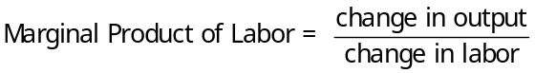

a. As the amount of labor used increases, the marginal product of labor falls.

b. Definition of diminishing marginal product: the property whereby the marginal product of an input declines as the quantity of the input increases.
Point out that diminishing marginal returns is a result of fixed inputs and, therefore is a short-run phenomenon.
ALTERNATIVE CLASSROOM EXAMPLE:
Consider the short-run production of a small firm that makes sweaters. These sweaters are made using a combination of labor and knitting machines. In the short run, the firm has signed a lease to rent one machine. Therefore, in the short run, the firm cannot vary the amount of knitting machines it uses. However, the firm can vary the amount of labor it employs.

The first two columns in the table below show the production level that the firm can achieve at various amounts of labor:

Labor (# workers) | Total Output | Marginal Product
0 | 0 | ---
1 | 4 | 4
2 | 10 | 6
3 | 13 | 3
4 | 15 | 2
5 | 16 | 1

4. We can draw a graph of the firm's production function by plotting the level of labor (x-axis) against the level of output (y-axis).

Figure 2

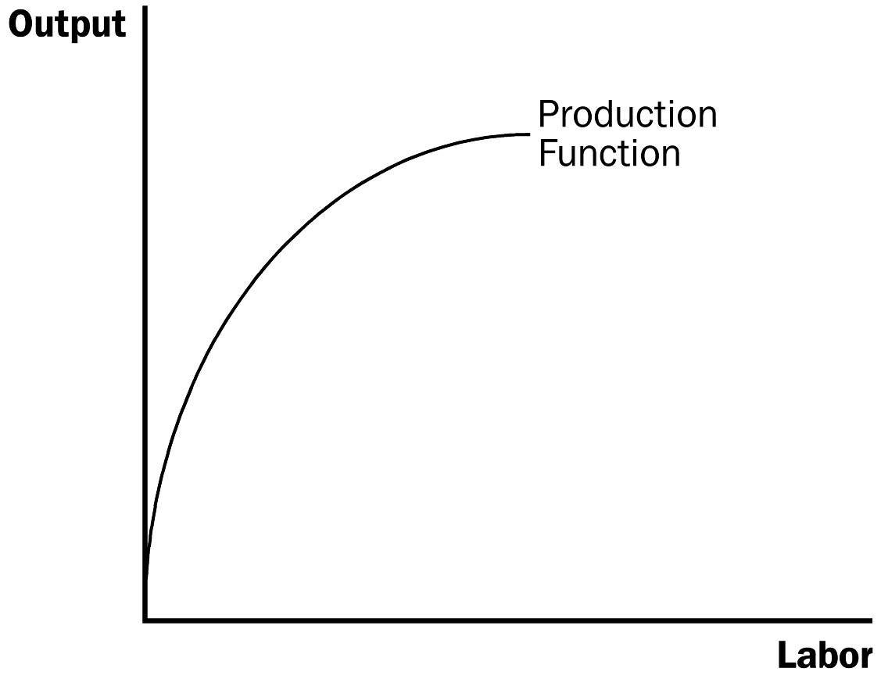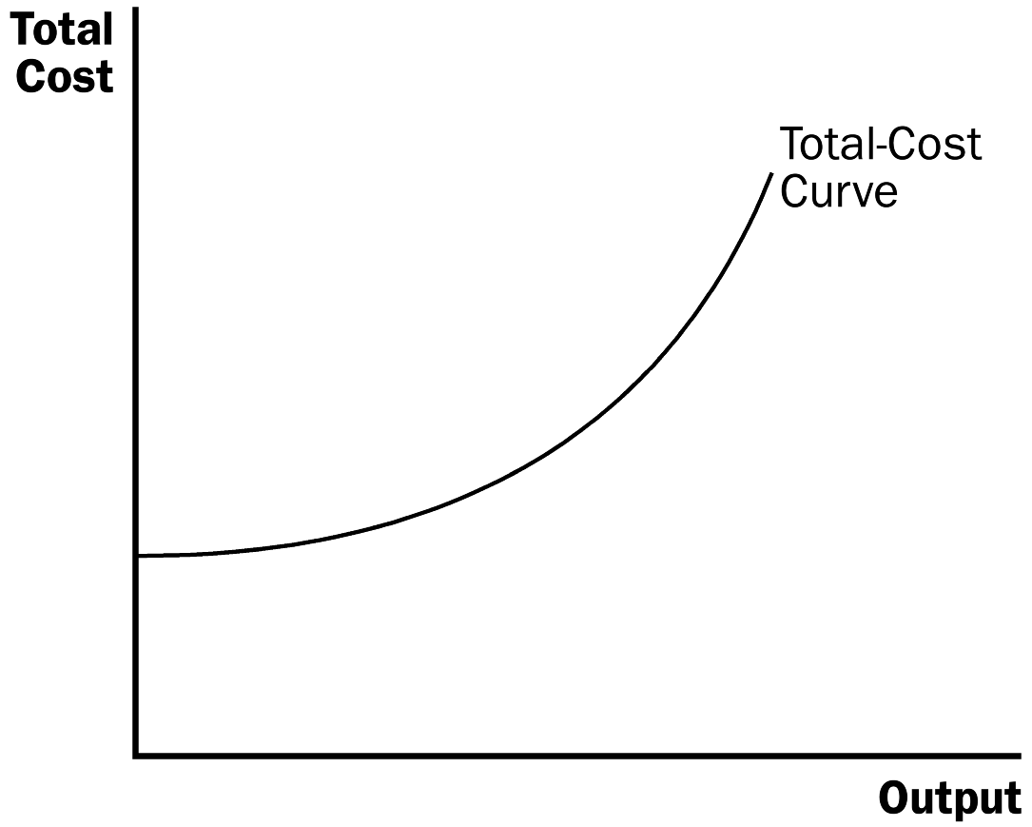

a. The slope of the production function measures marginal product.

b. Diminishing marginal product can be seen from the fact that the slope falls as the amount of labor used increases.

B. From the Production Function to the Total-Cost Curve

1. We can draw a graph of the firm's total cost curve by plotting the level of output (x-axis) against the total cost of producing that output (y-axis).

a. The total cost curve gets steeper and steeper as output rises.

b. This increase in the slope of the total cost curve is also due to diminishing marginal product: As Caroline increases the production of cookies, her kitchen becomes overcrowded, and she needs a lot more labor.

Activity 1—Growing Rice on a Chalkboard

Type: In-class demonstration
Topics: Diminishing returns and increasing costs
Materials needed: Chalkboard and chalk
Time: 25 minutes
Class limitations: Works in classes with more than 15 students

Purpose
Students often have difficulty understanding why diminishing returns exist in short-run production. This activity vividly demonstrates how fixed factors constrain the returns to variable inputs. Then the cause of increasing marginal cost is obvious.

Instructions
Prepare the game by selecting two volunteers and outlining two rectangular areas on the chalkboard, approximately 2 × 3 feet. Next to each area, label a column “Labor” and another “Total Output.” Give each volunteer one piece of chalk and hide any other pieces. The chalk is a fixed factor of production.

The volunteers are farmers and the outlined areas are their farm fields. They produce rice by writing the word “RICE” in large letters inside their own field. The letters need to be at least three inches high. They want to produce as much rice as possible in each 15-second time period.

The variable input in this example is labor. The game is played repeatedly, adding another student each period. Eventually five students will be crowded around each “field” trying to write with a tiny piece of chalk.

The constraints from the fixed factors are physically demonstrated.

Start the game with zeros in both the labor and total output columns; with no labor, no rice is produced. Then have the two volunteers race to see how much they can produce in 15 seconds. Record their production under “Total Output” with one “Labor.”

III. The Various Measures of Cost

A. Example: Conrad’s Coffee Shop
Table 2

Output | Total Cost | Fixed Cost | Variable Cost | Average Fixed Cost | Average Variable Cost | Average Total Cost | Marginal Cost
0 | $3.00 | $3.00 | $0 | --- | --- | --- | ---
1 | 3.30 | 3.00 | 0.30 | $3.00 | $0.30 | $3.30 | $0.30
2 | 3.80 | 3.00 | 0.80 | 1.50 | 0.40 | 1.90 | 0.50
3 | 4.50 | 3.00 | 1.50 | 1.00 | 0.50 | 1.50 | 0.70
4 | 5.40 | 3.00 | 2.40 | 0.75 | 0.60 | 1.35 | 0.90
5 | 6.50 | 3.00 | 3.50 | 0.60 | 0.70 | 1.30 | 1.10
6 | 7.80 | 3.00 | 4.80 | 0.50 | 0.80 | 1.30 | 1.30
7 | 9.30 | 3.00 | 6.30 | 0.43 | 0.90 | 1.33 | 1.50
8 | 11.00 | 3.00 | 8.00 | 0.38 | 1.00 | 1.38 | 1.70
9 | 12.90 | 3.00 | 9.90 | 0.33 | 1.10 | 1.43 | 1.90
10 | 15.00 | 3.00 | 12.00 | 0.30 | 1.20 | 1.50 | 2.10

Figure 3

ALTERNATIVE CLASSROOM EXAMPLE:
Consider the sweater manufacturer (described earlier). The firm is currently renting one machine for $25 per day. Each worker is also paid $25 per day.

Labor | Output | Fixed Cost | Variable Cost | Total Cost | Average Fixed Cost | Average Variable Cost | Average Total Cost | Marginal Cost
0 | 0 | $25 | $0 | $25 | ---- | ---- | ---- | ----
1 | 4 | 25 | 25 | 50 | $6.25 | $6.25 | $12.50 | $6.25
2 | 10 | 25 | 50 | 75 | 2.50 | 5.00 | 7.50 | 4.17
3 | 13 | 25 | 75 | 100 | 1.92 | 5.77 | 7.69 | 8.33
4 | 15 | 25 | 100 | 125 | 1.67 | 6.67 | 8.33 | 12.50
5 | 16 | 25 | 125 | 150 | 1.56 | 7.81 | 9.38 | 25.00

B. Fixed and Variable Costs

1. Definition of fixed costs: costs that do not vary with the quantity of output produced.

2. Definition of variable costs: costs that do vary with the quantity of output produced.

3. Total cost is equal to fixed cost plus variable cost.
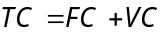

C. Average and Marginal Cost

1. Definition of average total cost: total cost divided by the quantity of output.

2. Definition of average fixed cost: fixed costs divided by the quantity of output.

3. Definition of average variable cost: variable costs divided by the quantity of output.

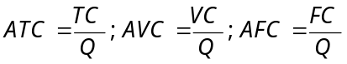

4. Definition of marginal cost: the increase in total cost that arises from an extra unit of production.

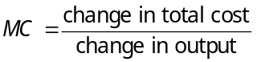

5. Average total cost tells us the cost of a typical unit of output and marginal cost tells us the cost of an additional unit of output.

D. Cost Curves and Their Shapes
Figure 4

1. Rising Marginal Cost

a. This occurs because of diminishing marginal product.

b. At a low level of output, there are few workers and a lot of idle equipment. But as output increases, the coffee shop gets crowded and the cost of producing another unit of output becomes high.

2. U-Shaped Average Total Cost

a. Average total cost is the sum of average fixed cost and average variable cost.
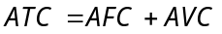

b. AFC declines as output expands and AVC typically increases as output expands. AFC is high when output levels are low. As output expands, AFC declines pulling ATC down. As fixed costs get spread over a large number of units, the effect of AFC on ATC falls and ATC begins to rise because of diminishing marginal product.

c. Definition of efficient scale: the quantity of output that minimizes average total cost.

3. The Relationship between Marginal Cost and Average Total Cost

a. Whenever marginal cost is less than average total cost, average total cost is falling. Whenever marginal cost is greater than average total cost, average total cost is rising.

b. The marginal-cost curve crosses the average-total-cost curve at minimum average total cost (the efficient scale).

Activity 2—Average and Marginal Grades

Type: In-class demonstration
Topics: Relationship between marginal and average cost
Materials needed: None
Time: 5 minutes
Class limitations: Works in any size class

Purpose
This quick exercise uses an analogy to illustrate to students that they already know the relation between marginal values and averages.

Instructions
Tell the class that two twins (Miley and Hannah) are enrolled in Principles of Economics. They each had a “B” average (GPA = 3.0) before taking the class.

Miley gets a “C” in the course. What happens to her GPA?

Hannah gets an “A” in the class. What happens to her GPA?

Common Answers and Points for Discussion
Students will likely know that Miley will have a lower GPA and Hannah a higher GPA. A “marginal” grade lower than the average will pull down the average. A “marginal” grade higher than the average will increase the average.

The same is true of marginal cost and average costs. If marginal cost is less than average cost, average cost will fall. If marginal cost is higher than average cost, average cost will rise.

4. Typical Cost Curves
Figure 5

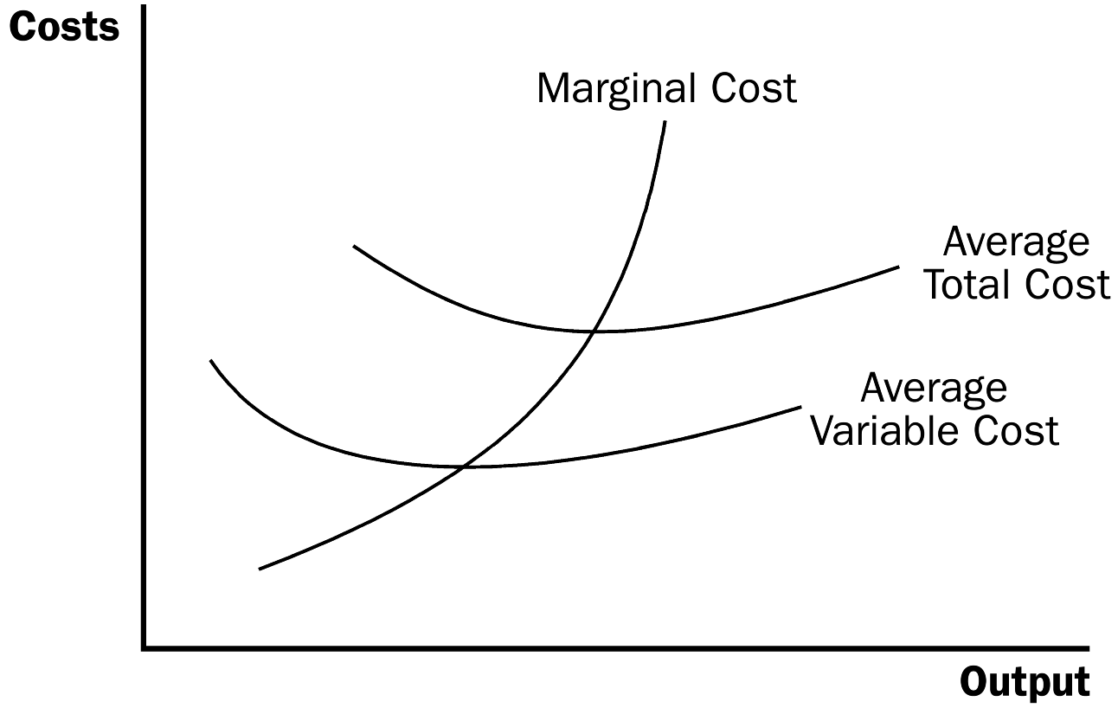

a. Marginal cost eventually rises with output.

b. The average-total-cost curve is U-shaped.

c. Marginal cost crosses average total cost at the minimum of average total cost.
Emphasize that these cost curves include ALL costs for the resources needed to produce the good. Thus, both explicit costs and implicit costs are included.

IV. Costs in the Short Run and in the Long Run

A. The division of total costs into fixed and variable costs will vary from firm to firm.

B. Some costs are fixed in the short run, but all are variable in the long run.

1. For example, in the long run a firm could choose the size of its factory.

2. Once a factory is chosen, the firm must deal with the short-run costs associated with that plant size.

C. The long-run average-total-cost curve lies along the lowest points of the short-run average-total-cost curves because the firm has more flexibility in the long run to deal with changes in production.
Figure 6
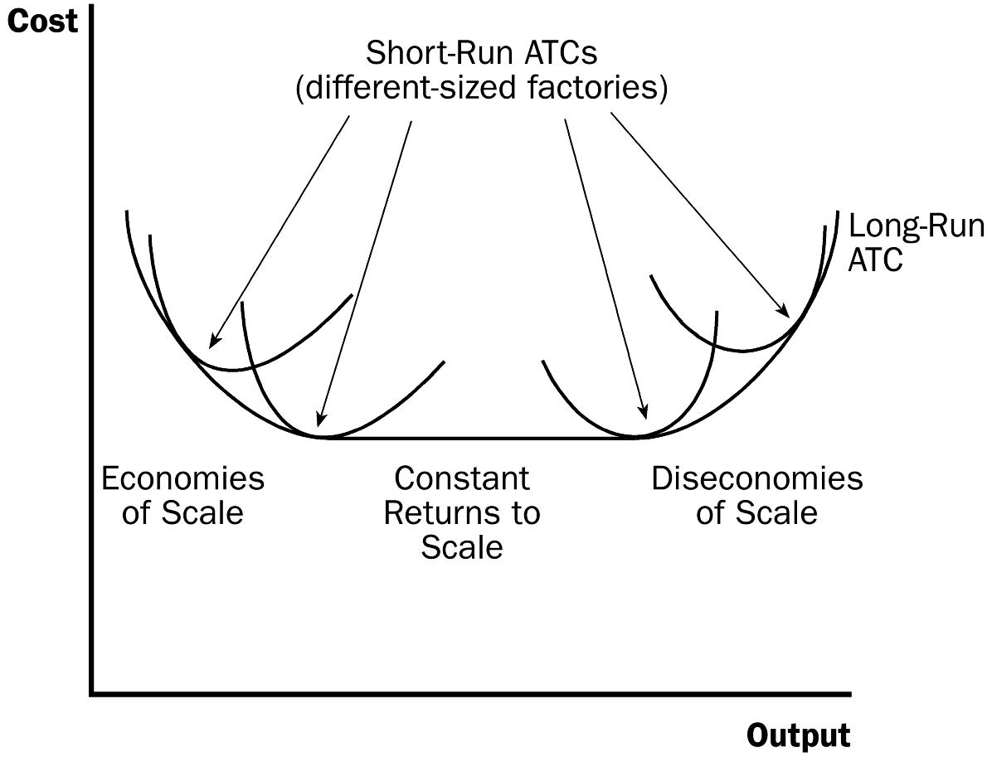

D. The long-run average-total-cost curve is typically U-shaped, but is much flatter than a typical short-run average-total-cost curve.

E. The length of time for a firm to get to the long run will depend on the firm involved.

F. Economies and Diseconomies of Scale

1. Definition of economies of scale: the property whereby long-run average total cost falls as the quantity of output increases.

2. Definition of diseconomies of scale: the property whereby long-run average total cost rises as the quantity of output increases.

3. Definition of constant returns to scale: the property whereby long-run average total cost stays the same as the quantity of output changes.
4. FYI: Lessons from a Pin Factory

a. In The Wealth of Nations, Adam Smith described how specialization in a pin factory allowed output to be greater than it would have been if each worker attempted to perform many different tasks.

b. The use of specialization allows firms to achieve economies of scale.

V. Table 3 provides a summary of all of the various cost definitions used throughout this chapter.

Table 3

SOLUTIONS TO TEXT PROBLEMS:

Quick Quizzes

1. Farmer McDonald’s opportunity cost is $300, consisting of 10 hours of lessons at $20 an hour that he could have been earning plus $100 in seeds. His accountant would only count the explicit cost of the seeds ($100). If McDonald earns $200 from selling the crops, then McDonald earns a $100 accounting profit ($200 sales minus $100 cost of seeds) but incurs an economic loss of $100 ($200 sales minus $300 opportunity cost).

2. Farmer Jones’s production function is shown in Figure 1 and his total-cost curve is shown in Figure 2. The production function becomes flatter as the number of bags of seeds increases because of the diminishing marginal product of seeds. The total-cost curve gets steeper as the amount of production increases. This feature is also due to the diminishing marginal product of seeds, since each additional bag of seeds generates a lower marginal product, and thus, the cost of producing additional bushels of wheat rises.

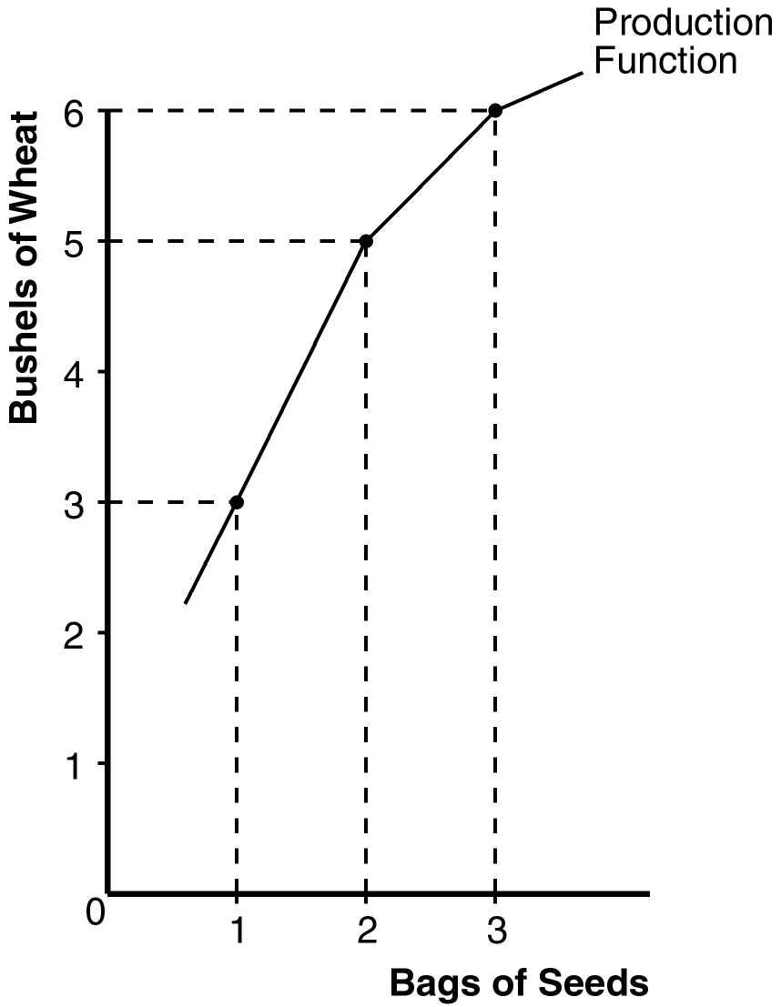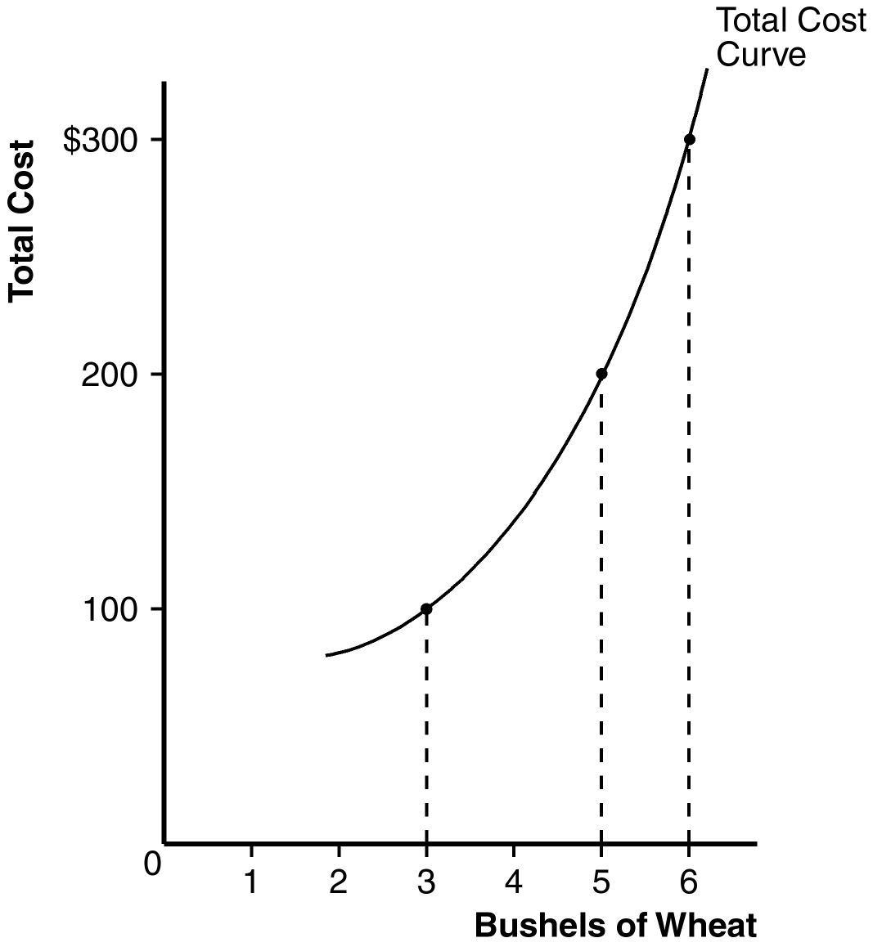

Figure 1 Figure 2

3. The average total cost of producing 5 cars is $250,000/5 = $50,000. Since total cost rose from $225,000 to $250,000 when output increased from 4 to 5, the marginal cost of the fifth car is $25,000.

The marginal-cost curve and the average-total-cost curve for a typical firm are shown in Figure 3. They cross at the efficient scale because at low levels of output, marginal cost is below average total cost, so average total cost is falling. But after the two curves cross, marginal cost rises above average total cost, and average total cost starts to rise. So the point of intersection must be the minimum of average total cost.

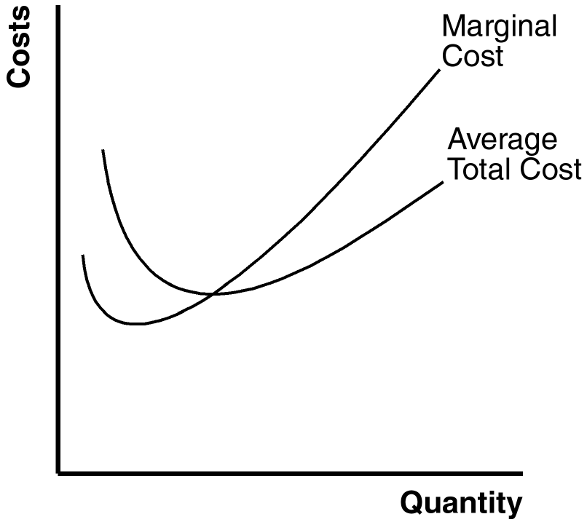

Figure 3

4. The long-run average total cost of producing 9 planes is $9 million/9 = $1 million. The long-run average total cost of producing 10 planes is $9.5 million/10 = $0.95 million. Since the long-run average total cost declines as the number of planes increases, Boeing exhibits economies of scale.

Questions for Review

1. The relationship between a firm's total revenue, profit, and total cost is profit equals total revenue minus total costs.

2. An accountant would not count the owner’s opportunity cost of alternative employment as an accounting cost. An example is given in the text in which Caroline runs a cookie business, but she could instead work as a computer programmer. Because she's working in her cookie factory, she gives up the opportunity to earn $100 per hour as a computer programmer. The accountant ignores this opportunity cost because money does not flow into or out of the firm. But the cost is relevant to Caroline’s decision to run the cookie factory.

3. Marginal product is the increase in output that arises from an additional unit of input. Diminishing marginal product means that the marginal product of an input declines as the quantity of the input increases.

4. Figure 4 shows a production function that exhibits diminishing marginal product of labor. Figure 5 shows the associated total-cost curve. The production function is concave because of diminishing marginal product, while the total-cost curve is convex for the same reason.

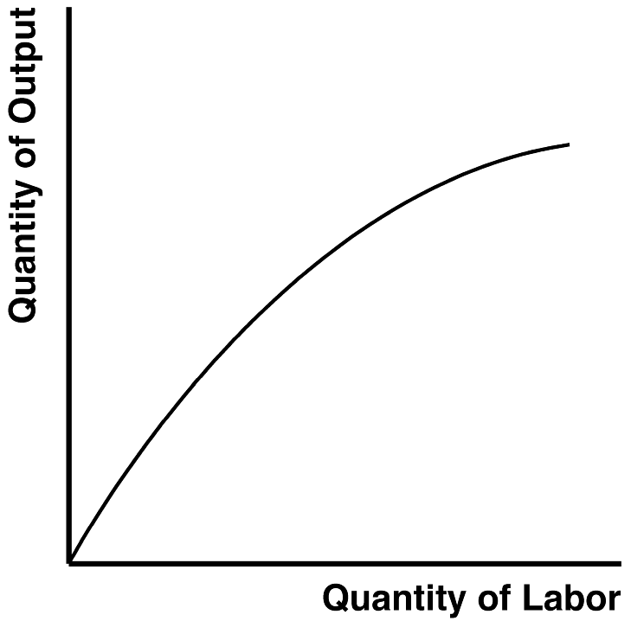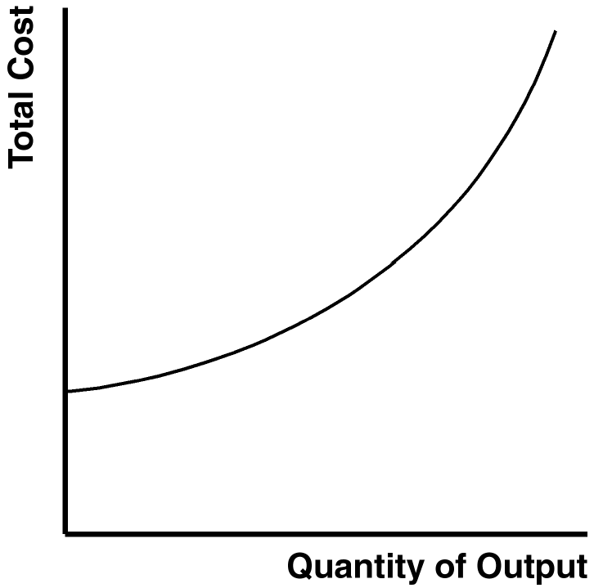

Figure 4 Figure 5

5. Total cost consists of the costs of all inputs needed to produce a given quantity of output. It includes fixed costs and variable costs. Average total cost is the cost of a typical unit of output and is equal to total cost divided by the quantity produced. Marginal cost is the cost of producing an additional unit of output and is equal to the change in total cost divided by the change in quantity. An additional relation between average total cost and marginal cost is that whenever marginal cost is less than average total cost, average total cost is declining; whenever marginal cost is greater than average total cost, average total cost is rising.

Figure 6

6. Figure 6 shows the marginal-cost curve and the average-total-cost curve for a typical firm. There are three main features of these curves: (1) marginal cost is U-shaped but rises sharply as output increases; (2) average total cost is U-shaped; and (3) whenever marginal cost is less than average total cost, average total cost is declining; whenever marginal cost is greater than average total cost, average total cost is rising. Marginal cost is increasing for output greater than a certain quantity because of diminishing returns. The average-total-cost curve is downward-sloping initially because the firm is able to spread out fixed costs over additional units. The average-total-cost curve is increasing beyond some output level because as quantity increases, the demand for important variable inputs increases; therefore, the cost of these inputs increases. The marginal-cost and average-total-cost curves intersect at the minimum of average total cost; that quantity is the efficient scale.

7. In the long run, a firm can adjust the factors of production that are fixed in the short run; for example, it can increase the size of its factory. As a result, the long-run average-total-cost curve has a much flatter U-shape than the short-run average-total-cost curve. In addition, the long-run curve lies along the lower envelope of the short-run curves.

8. Economies of scale exist when long-run average total cost decreases as the quantity of output increases, which occurs because of specialization among workers. Diseconomies of scale exist when long-run average total cost rises as the quantity of output increases, which occurs because of the coordination problems inherent in a large organization.

Quick Check Multiple Choice

1. a

2. d

3. d

4. c

5. b

6. a

Problems and Applications

1. a. opportunity cost; b. average total cost; c. fixed cost; d. variable cost; e. total cost; f. marginal cost.

2. a. The opportunity cost of something is what must be given up to acquire it.

b. The opportunity cost of running the hardware store is $550,000, consisting of $500,000 to rent the store and buy the stock and a $50,000 implicit cost, because your aunt would quit her job as an accountant to run the store. Because the total opportunity cost of $550,000 exceeds the projected revenue of $510,000, your aunt should not open the store, as her economic profit would be negative.

3. a. The following table shows the marginal product of each hour spent fishing:

Hours | Fish | Fixed Cost | Variable Cost | Total Cost | Marginal Product
0 | 0 | $10 | $0 | $10 | ---
1 | 10 | 10 | 5 | 15 | 10
2 | 18 | 10 | 10 | 20 | 8
3 | 24 | 10 | 15 | 25 | 6
4 | 28 | 10 | 20 | 30 | 4
5 | 30 | 10 | 25 | 35 | 2

b. Figure 7 graphs the fisherman's production function. The production function becomes flatter as the number of hours spent fishing increases, illustrating diminishing marginal product.

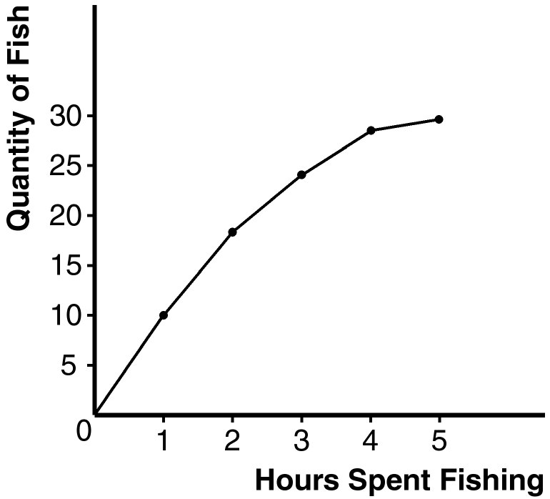

Figure 7

c. The table shows the fixed cost, variable cost, and total cost of fishing. Figure 8 shows the fisherman's total-cost curve. It has an upward slope because catching additional fish takes additional time. The curve is convex because there are diminishing returns to fishing time because each additional hour spent fishing yields fewer additional fish.

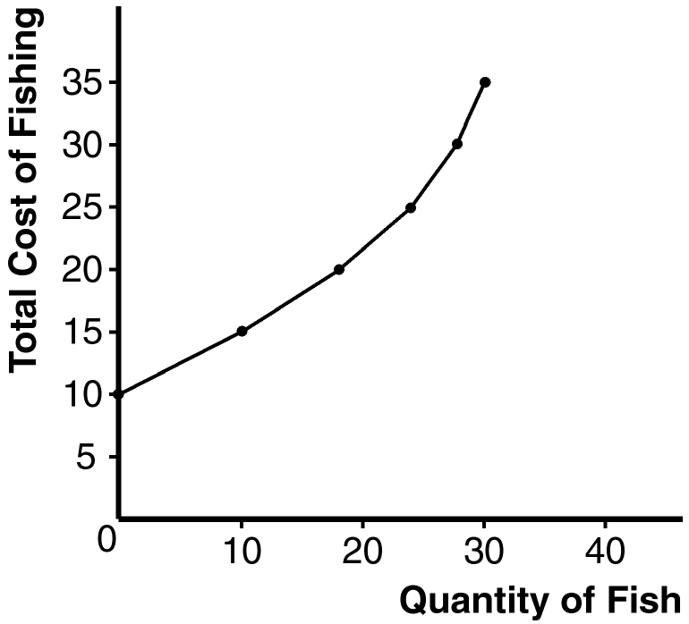

Figure 8

4. Here is the completed table:

Workers | Output | Marginal Product | Total Cost | Average Total Cost | Marginal Cost
0 | 0 | --- | $200 | --- | ---
1 | 20 | 20 | 300 | $15.00 | $5.00
2 | 50 | 30 | 400 | 8.00 | 3.33
3 | 90 | 40 | 500 | 5.56 | 2.50
4 | 120 | 30 | 600 | 5.00 | 3.33
5 | 140 | 20 | 700 | 5.00 | 5.00
6 | 150 | 10 | 800 | 5.33 | 10.00
7 | 155 | 5 | 900 | 5.81 | 20.00

a. See the table for marginal product. Marginal product rises at first, then declines because of diminishing marginal product.

b. See the table for total cost.

c. See the table for average total cost. Average total cost is U-shaped. When quantity is low, average total cost declines as quantity rises; when quantity is high, average total cost rises as quantity rises.

d. See the table for marginal cost. Marginal cost is also U-shaped, but rises steeply as output increases. This is due to diminishing marginal product.

e. When marginal product is rising, marginal cost is falling, and vice versa.

f. When marginal cost is less than average total cost, average total cost is falling; the cost of the last unit produced pulls the average down. When marginal cost is greater than average total cost, average total cost is rising; the cost of the last unit produced pushes the average up.

5. At an output level of 600 players, total cost is $180,000 (600 × $300). The total cost of producing 601 players is $180,901. Therefore, you should not accept the offer of $550, because the marginal cost of the 601st player is $901.

6. a. The fixed cost is $300, because fixed cost equals total cost minus variable cost. At an output of zero, the only costs are fixed cost.

b.
Quantity | Total Cost | Variable Cost | Marginal Cost (using total cost) | Marginal Cost  (using variable cost)
0 | $300 | $0 | --- | ---
1 | 350 | 50 | $50 | $50
2 | 390 | 90 | 40 | 40
3 | 420 | 120 | 30 | 30
4 | 450 | 150 | 30 | 30
5 | 490 | 190 | 40 | 40
6 | 540 | 240 | 50 | 50

Marginal cost equals the change in total cost for each additional unit of output. It is also equal to the change in variable cost for each additional unit of output. This relationship occurs because total cost equals the sum of variable cost and fixed cost and fixed cost does not change as the quantity changes. Thus, as quantity increases, the increase in total cost equals the increase in variable cost.

7. The following table illustrates average fixed cost (AFC), average variable cost (AVC), and average total cost (ATC) for each quantity. The efficient scale is 4 houses per month, because that minimizes average total cost.

Quantity | Variable Cost | Fixed Cost | Total Cost | Average Fixed Cost | Average Variable Cost | Average Total Cost
0 | $0.00 | $200.00 | $200.00 | --- | --- | ---
1 | 10.00 | 200.00 | 210.00 | $200.00 | $10.00 | $210.00
2 | 20.00 | 200.00 | 220.00 | 100.00 | 10.00 | 110.00
3 | 40.00 | 200.00 | 240.00 | 66.67 | 13.33 | 80.00
4 | 80.00 | 200.00 | 280.00 | 50.00 | 20.00 | 70.00
5 | 160.00 | 200.00 | 360.00 | 40.00 | 32.00 | 72.00
6 | 320.00 | 200.00 | 520.00 | 33.33 | 53.33 | 86.67
7 | 640.00 | 200.00 | 840.00 | 28.57 | 91.43 | 120.00

8. a. The lump-sum tax causes an increase in fixed cost. Therefore, as Figure 10 shows, only average fixed cost and average total cost will be affected.

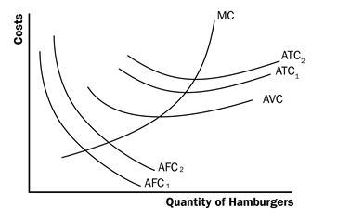

Figure 10

b. Refer to Figure 11. Average variable cost, average total cost, and marginal cost will all be greater. Average fixed cost will be unaffected.

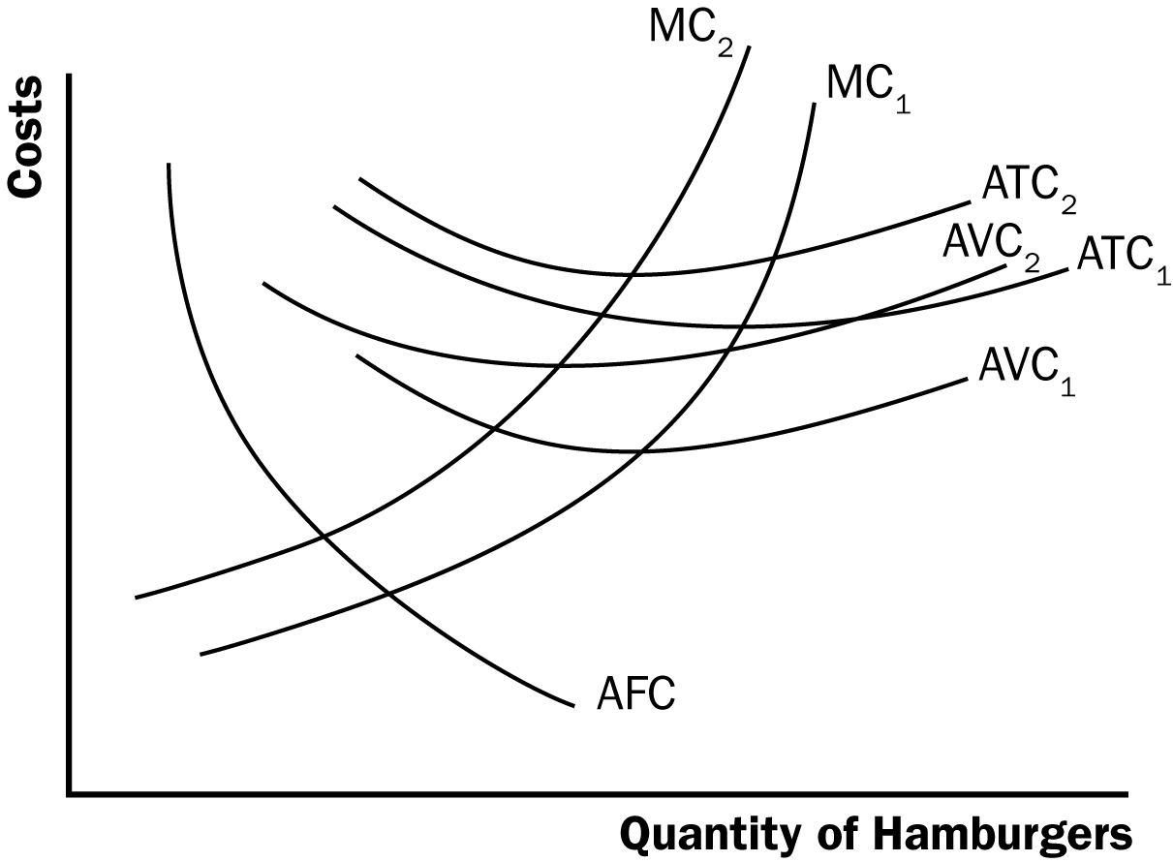

Figure 11

9. a. The following table shows average variable cost (AVC), average total cost (ATC), and marginal cost (MC) for each quantity.

Quantity | Variable Cost | Total Cost | Average Variable Cost | Average Total Cost | Marginal Cost
0 | $0.00 | $30.00 | --- | --- | ---
1 | 10.00 | 40.00 | $10.00 | $40.00 | $10.00
2 | 25.00 | 55.00 | 12.50 | 27.50 | 15.00
3 | 45.00 | 75.00 | 15.00 | 25.00 | 20.00
4 | 70.00 | 100.00 | 17.50 | 25.00 | 25.00
5 | 100.00 | 130.00 | 20.00 | 26.00 | 30.00
6 | 135.00 | 165.00 | 22.50 | 27.50 | 35.00

b. Figure 12 shows the three curves. The marginal-cost curve is below the average-total-cost curve when output is less than four and average total cost is declining. The marginal-cost curve is above the average-total-cost curve when output is above four and average total cost is rising. The marginal-cost curve lies above the average-variable-cost curve.

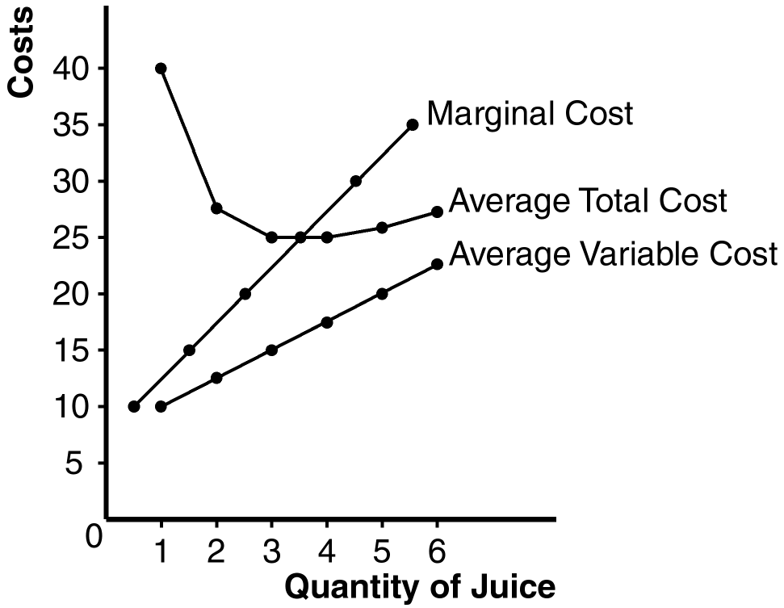

Figure 12

10. The following table shows quantity (Q), total cost (TC), and average total cost (ATC) for the three firms:

 | Firm A |  | Firm B |  | Firm C
Quantity | TC | ATC | TC | ATC | TC | ATC
1 | $60.00 | $60.00 | $11.00 | $11.00 | $21.00 | $21.00
2 | 70.00 | 35.00 | 24.00 | 12.00 | 34.00 | 17.00
3 | 80.00 | 26.67 | 39.00 | 13.00 | 49.00 | 16.33
4 | 90.00 | 22.50 | 56.00 | 14.00 | 66.00 | 16.50
5 | 100.00 | 20.00 | 75.00 | 15.00 | 85.00 | 17.00
6 | 110.00 | 18.33 | 96.00 | 16.00 | 106.00 | 17.67
7 | 120.00 | 17.14 | 119.00 | 17.00 | 129.00 | 18.43

Firm A has economies of scale because average total cost declines as output increases. Firm B has diseconomies of scale because average total cost rises as output rises. Firm C has economies of scale from one to three units of output and diseconomies of scale for levels of output beyond three units.

